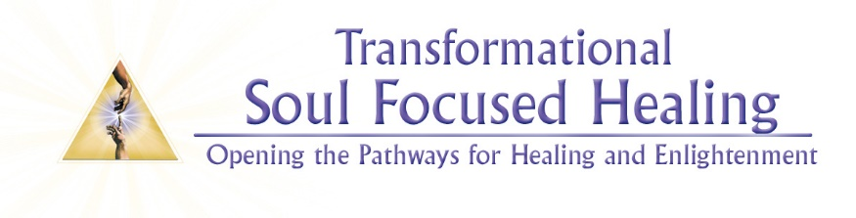
Soul Focused Healing is a precise, scientific system of Energy Medicine that works through the 7 chakras of the body and the 5 chakras of the Soul. This system interconnects the anatomy of the physical body with its reflection in the energy or electromagnetic field surrounding the body. The chakra system regulates vital energy into the body, its tissues, glands and Systems.
SFH works directly with the innate intelligence of the body and Soul to uncover the causal level of dis-ease and dis-harmony in the system, releasing old emotional and mental patterns and blocked energy. Restricted and distorted flow of energy is the root cause of patterns of dis-ease and dis-harmony at all levels of physical, emotional, mental and spiritual wellbeing.
When the energy body or Aura is clear and balanced it allows the innate intelligence and the divine wisdom of the Soul to express itself freely through the personality and the physical body, thus aiding the embodiment of our True Self.

SOUL FOCUSED HEALING: BASIC Level Training
This is a live, in-person Level 1 Theory and Practice course which will include:
- The 7 Chakras of the body, their Organs and Glands
- Energy Anatomy and Physiology
- Sensing and Feeling Energy
- Guided Meditations
- Distance Healing
Dates: 4 Day Intensive Course 17-18. September und 24-25. September
Times: 9:00 – 12:00 and 14:00 - 17:00
Place: Gruppenraum, Lobuschstraße 12, 22765 Hamburg (Ottensen – 5 Minutes from Altona S-Bahn)
Cost: 360€ payment in Full by 1. August; all Registrations after 1. August 380€
Registration: Paula van Tuyl, www.heilpraktikerin-vantuyl.de or e-Mail: info@bewusst-eins.de

About Paula van Tuyl:
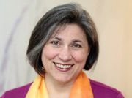
Paula is a gifted healer, mentor and Soul Focused Healing Teacher who lives in Germany. Paula has been doing healing work in various forms for over the last 22 years. She brings physical, psychological and spiritual knowledge and wisdom together, supporting students and clients on their evolutionary journey and helping them to find and nurture their unique Soul expression in life.

